## User Guide

The application’s folder contains a database file in SQL format. The file name is **“fundhunt.sql”.**



Figure 40: Database SQL file

This database contains all the user information, food, restaurants, and cuisines in the app. It can be imported into phpMyAdmin.

The configuration file is found in the **"include"** folder. The file name is **"function4user.php".**



Figure 41: Database Configuration file location

The database configuration details can be changed to run on any server. The default database configuration details are shown in the screenshot below.

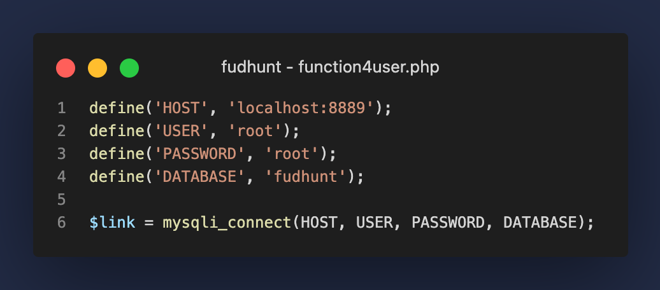

Figure 42: Database Configuration details